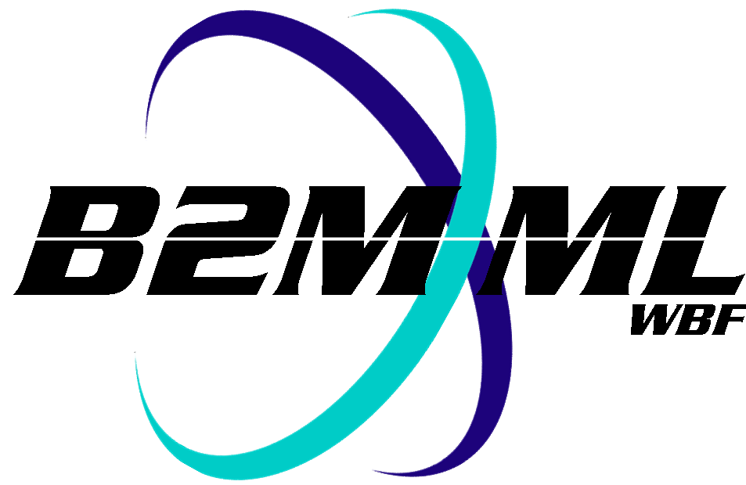
Business to Manufacturing Markup Language
Version 0401
B2MML Mapping Sheets

The B2MML schemas define the structure and format for exchanged data. They do not however define how the exchanged information is mapped into applications participating in the data exchange. The B2MML Mapping Sheets provide a method to define and document how exchanged information is mapped into the standard (B2MML) format and into each application's local names. They provide a method to document how the local application data elements map into a B2MML document.
The application data may be sourced from, or copied to flat files, database tables, proprietary XML, or other application specific methods.
Legacy applications will invariably have their local names for data elements. It is rare that these will line up across applications. For example one application may use the term “Product Code” while another application may use “Item Master Number”, with the data item stored in a MaterialDefinition/ID element. The B2MML mapping spreadsheets provide the tools to document the application's local names and where they reside in a B2MML document.
The mapping sheets and documentation can be freely used and are available at:
www.wbf.org

